Write With AI
Why specificity is the secret to irresistible headlines

Nicolas Cole
May 02, 2025

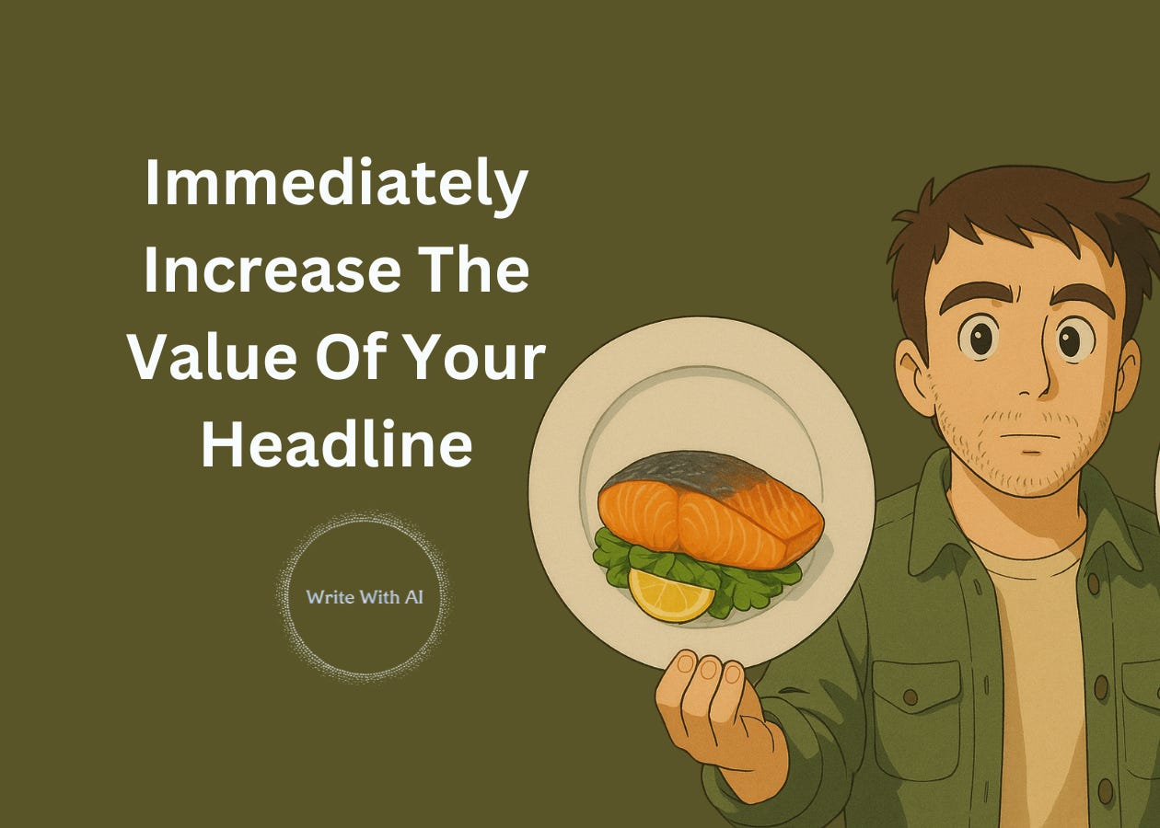

Ever notice how a skilled chef doesn't just say "fish with vegetables"?
They say "pan-seared wild-caught salmon with crispy skin, served over a bed of fresh spring vegetables finished with a light lemon butter cream sauce."
Your headlines need the same treatment.
The problem?
Most headlines are the content marketing equivalent of "fish with vegetables" - technically accurate but utterly forgettable.
They lack specificity.
The more specific your headline, the more universal it feels to your reader.
When you say "improve your writing," nobody feels spoken to.
But when you say "fix the 3 grammar mistakes that make you sound unprofessional in emails," suddenly everyone wonders if they're making those mistakes. That's the power of specificity.
The more specific your headline, the more likely the right reader is going to engage with your content.
For 3 reasons:
Reason #1: Specificity makes readers believe you actually know what you're talking about.
Vague headlines make you sound like everyone else.
But specific headlines signal expertise and authority. They tell readers: "This person has actually done the work."
Compare these two headlines:
- How to grow your audience online
- How I grew my email list from 0 to 5,281 subscribers in 87 days by writing 250-word posts
The second headline gives the reader concrete evidence of results.
And that specificity creates instant credibility.
Reason #2: Specificity creates a curiosity gap that's impossible to ignore.
Generic headlines don't make readers wonder anything.
But specific headlines raise questions in their minds:
- "How exactly did they do that?"
- "What are those 3 specific reasons?"
- "Could I achieve the same results?"
When you add unusual or unexpected details to your headline, you create what psychologists call a "curiosity gap" — the space between what someone knows and what they want to know.
This gap is literally irresistible to the human brain.
Take these examples:
- "How to Make Money" vs. "How This 62-Year-Old Librarian Makes $11,000/Month Flipping Vintage Books Found at Estate Sales"
- "Tips for Better Sleep" vs. "The 4-7-8 Breathing Method That Helps Navy SEALs Fall Asleep in 2 Minutes Flat"
See the difference?
Reason #3: Specificity filters out the wrong readers.
This is arguably the most powerful benefit.
When your headline gets ultra-specific, it automatically repels people who aren't your target audience—and that's a good thing!
You don't want tire-kickers and casual browsers.
You want engaged readers who are likely to take action on your content.
A good exercise you can use here is:
Start by just listing out all the things you target reader wants.
Then pick the top 3. You know your target reader wants & cares about those 3 things, so… say those 3 things in the headline!
And then increase your specificity.
- Add numbers: Use exact, odd, or unusual numbers. "7 Ways..." is fine, but "17 Ways..." is better. "Increase conversions by 300%" is okay, but "Increase conversions by 317%" is much more believable.
- Include timeframes: "How to Lose Weight" vs. "How to Lose 14 Pounds in the Next 28 Days Even If You've Failed at Every Other Diet"
- Name a method: "My 'Pyramid Pitch Method' That Closed $2.1M in New Business Last Quarter"
- Call out your exact audience: "For Busy Corporate Lawyers Who Bill 70+ Hours Per Week"
- Or add unusual details: "...While Only Using Your iPhone and a $20 Ring Light from Amazon"
Specificity IS the secret to attracting attention on the internet.
And if you need help…
Try this ChatGPT prompt to transform any bland headline into a laser-focused, reader-specific attention magnet:
Grab a headline you want to improve.
Insert the headline and your target audience into the prompt.
Then run it using your favorite LLM (ChatGPT, Claude, etc.).
Help me add precision and specificity to this headline:

My current headline:

[INSERT YOUR HEADLINE]

My target audience:

[INSERT YOUR TARGET READER]

Please create 5 "specific" versions that:

1) Add specificity through:
• Exact numbers/metrics (not "more traffic" but "47% more traffic")
• Precise audience identification (not "for businesses" but "for female founders with <5 employees")
• Concrete time frames (not "fast results" but "results in 14 days")
• Exact obstacles overcome ("even if you've failed at this 3 times before")
• Specific contexts/situations ("during your morning commute")

2) For each version, explain:
• Which specificity elements you added
• Why this makes the headline more compelling
• Who exactly would feel this headline was written just for them

Make my headline feel like it was custom-tailored for my exact reader!
This prompt helps you upgrade your headline by:
- Calling out your audience
- Adding tangible proof (numbers, results, context)
- Building curiosity with specific, unusual details
It seems minor, but adding specificity will improve your headline 10X.
But that’s not all!
There’s one more thing you can do to improve your headline performance.
Add "power words."
These are words that sweeten your headline to hit the reader’s emotional hot buttons (without crossing into clickbait territory).
For example:
- Simple
- Proven
- Underrated
- Life-changing
- Little-known
- Etc.
It's like adding just the right amount of sugar to your coffee -without sacrificing the flavor.
Add a “sweetener” in your hook with this prompt.
Pick one headline you like from the prompt above.
Or start with a new one.
Then run this next:
You are a Copy Sweetener Assistant.

Based on my headline or idea below, suggest 10 sweetener words I could add to make it feel more magnetic without sounding hypey or clickbaity.

Suggest words or phrases that:
- Add curiosity
- Lower resistance
- Hint at something bigger
- Tease simplicity
- Make an idea feel smarter, easier, faster, or more valuable

Keep it grounded, smart, and curiosity-driven.

Headline/Idea:

{Insert}
Let’s look at what happens when you use this prompt.
Before: "How to Grow Your Email List"
After: "Why Your Email List is Growing at Half the Speed It Should Be (Quick Fix)"
The sweetened version:
- Triggers status anxiety ("half the speed it should be")
- Creates curiosity about the "quick fix"
- Implies you're missing out on potential growth
- Still delivers exactly what was promised
These descriptive enhancers transform a bland promise into a vivid, desirable outcome that readers can almost taste.
It's the difference between ordering "coffee" and a "rich, hand-crafted espresso with velvety microfoam."
Both deliver caffeine, but only one makes your mouth water.
Use these prompts today to give your headlines that "chef's special" quality that makes them impossible to scroll past.
That’s it.
—Dickie & Cole

